INDIVIDUAL REFLECTION

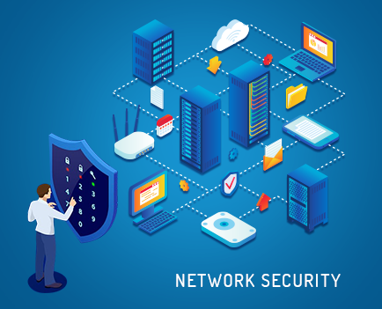

**LAYER 3 (NETWORK LAYER] INCRUSION**

SUBMITTED BY- ALISHA ADHIKARI

‘190095’/’10176139’

SUBMITTED TO – ABIJEET KARNA

ACHYUT TIMSINA

Our team “Core Four” was formed for the group assignment of Real-World Project, Me and my three classmates teamed up with same goal to analyze the faults in third layer i.e., Network Layer of the OSI Model. We had performed deep research of the Network layer, possible attacks and consequences to design our project. Within all of us in entire class, only our team was working on the projected related to layer 3, as it is quite complex to work on. We had Ashim Pradhan as a team leader and me, Sagar Khadka & Sabin Khatri worked as a team for the entire project. Since, I had already teamed up with Ashim Pradhan previously for the digital forensic assignment it was easy for me to work with him, though working as a team with Sagar Khadka and Sabin khatri was my first experience I didn’t had any difficulty teaming up with team.

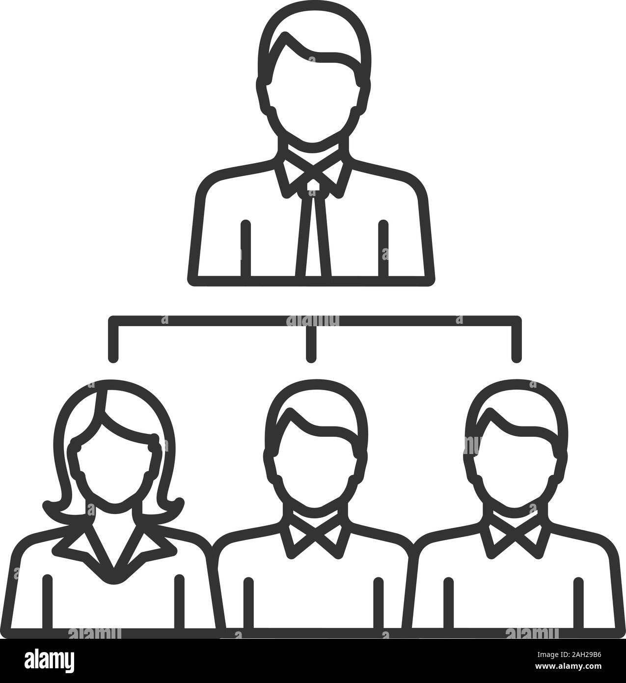

**F**

**O**

**U**

**R**

**C**

**O**

**R**

**E**

ASHIM PRADHAN

SABIN

SAGAR

ALISHA

As the topic we choose was quite complex, we had taken a lot of time for research on the topic to decide and plan what are we going to do, important topics that must be included in the project and so on. After a long research and discussion for more than 2 weeks we team decided to work on the offensive side and as well as defend the attacks we execute on the Network Layer. Though, we choose the topic for the project with motive to explore, push ourself to learn. But, the first month only went on research, discussion on how does it work, its key areas, attack accomplished till now, weakness, area of strength and everything from small-to-small information related to the layer.

As soon as the assignment was released and we were working on the research and the COVID19 cases with new variant raised up so, government had to shutdown the colleges. We conducted our group meetings for discussion through Microsoft Teams and Facebook Messenger. Since we didn’t have any idea on how to work on the project involving networking device without having it. We divided our project within our group and our team leader assigned each us of with topic to research and work on. We used to conduct meetings a day in every week to discuss, share issues we are facing on the project, share our learnings to one another.

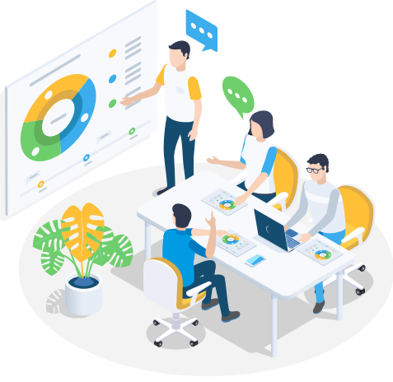



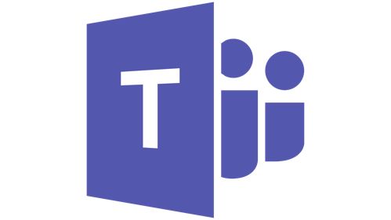

Network Layer Attack was the title we choose for the Project. It was an interesting as well as complex topic to work on and one could enhance lot of knowledge through it. The idea was to find the flaws and successfully accomplish all the possible attack as well as work to defense through the attack. The project was divided into four phases as research, development, testing and documentation. Each member of the team was responsible to perform at least two parts. After the research, all of the group members of the team combinedly started the development phase. Since, we had planned to work on both the offensive side as well as defensive part so all of us first worked on the offensive part or attack that could possibly be accomplished. Certainly, while working in the middle of the project me and my whole family got infected by the COVID19 and also within that time the other member of our team also got infected by the viral due to which we had to hold our part of project for more than two weeks. After me and my other team member overcome through the infection we got back to the project. Since, we had to lose our time due to the health issues we all teams decided not to work on the defensive part and only focus on the offensive part of the project.

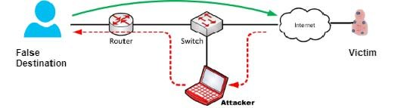

Within a team, working together by caring and sharing is most and also the efficiency and hard work is vital, when it comes to development. Similarly, being patient is most while implementing the development made. Throughout the implementation many times, we failed but didn’t lose our hopes. My two team members started working on the flaws of our project, one of them on development of GUI and me on the documentation part. Throughout our project me and my team followed the T7 model for an effective team work.

